Mobile Assignment Two – Math Game v1.0
<Name/Com3|FC|BBIS4//Email> ← fill in please & then pages 3+
- Design and implement an Android App that is a Maths game for children. The app ‘thinks’ of two numbers to add/subtract etc and the child must enter the answer. The app should include the following:

  - Basic functionality that addresses App’s purpose: at least 3 Activities and navigation between them. Simple UI components e.g. TextView, EditText & Button.

  - Use of 3 different layout managers on the 3 activities e.g. LinearLayout, TableLayout, RelativeLayout, FrameLayout etc.

  - Use a scoring system so the child sees how many right/wrong answers they got.

  - Include 3 different types of UI widgets e.g. Spinner, togglebutton, radiobutton, progressbar, imagebutton etc. but excluding TextView, Button & EditText. Process the events for 2 of the UI widgets.

  - 4 Menus items invoked by menu button. Process the events from the menu items e.g. launch another activity or web page, reset score etc.
(10 marks ea, 50 marks total)

2. Three Advanced features or innovation/creativity; here are some examples but you can do different ones if you want:

  - Extra app functionality not covered in 1(a)

  - Use of the notification manager and a pending intent that does something e.g. launches a web page.

  - API functionality not covered in lectures.
(10 marks ea, 30 marks total)

3. Documentation includes the following:
- Commented code & the use a coding standard. Use extra classes where appropriate.
- This document stating what done including screen shots of code snippets & the running app code (on pages 3+). App Specification (~½ page). List of classes and what each is for. Evaluation (~½ page in 3 bullet points): how has it worked out, what could be done differently & future outlook.
(10 marks ea, 20 marks total)

Assignment Procedure guide (includes a coding standard)

Demo in the lab (mandatory for on site courses):
- Demonstrate the running program in the 1st lab after the due date. You may be asked to make changes to the code after the demo. The purpose of the demo is to show what you have done and that you understand what you have done. There are no marks for the demo but failure to do one may impact your overall mark.

- Submission
Submit to Blackboard (ONLY): This edited document & Eclipse/Netbeans Project folder. All goes in 1 archive file. Please name the archive file with:
    - Course/Yr e.g. DCOM3, COM3, CLCO, BBIS4
    - yourName
    - subject e.g. MOB, GUI, AUI
    - Assignment number e.g. 1 or 2.

Examples:
    - COM3mickeyMouseAUI-Asn1.7z
    - CLCOfredFlintstoneMOB-Asn1.zip

“By submitting this electronically, using an account & password only I have access to, I hereby certify that this material which I now submit for assessment is entirely my own work and has not been taken from the work of others, save and to the extent, that such work has been cited and acknowledged within the text of my work.”

NB – CIT has access to plagiarism tools and these may be used on submitted assignments. The use of ‘rent a coder’ type services in preparing your assignment is forbidden.
Place each item of the assignment on a separate page stating if completed or not and showing screen shot(s) of code snippets and application screen(s). The code should be just a small screen shot snippet(s) showing where e.g. a component is created, listener assigned etc.
1 (a) <task description copied from page 1>
Completed? Yes
Code snipped screen shot(s) for 1(a)
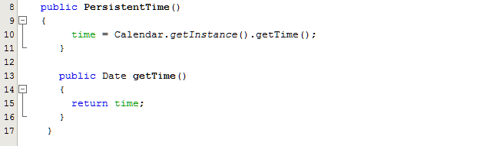

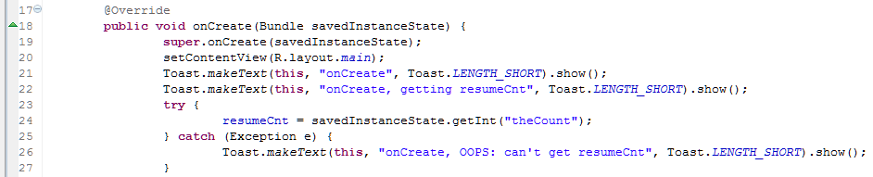

Application screen shot(s) for 1(a)
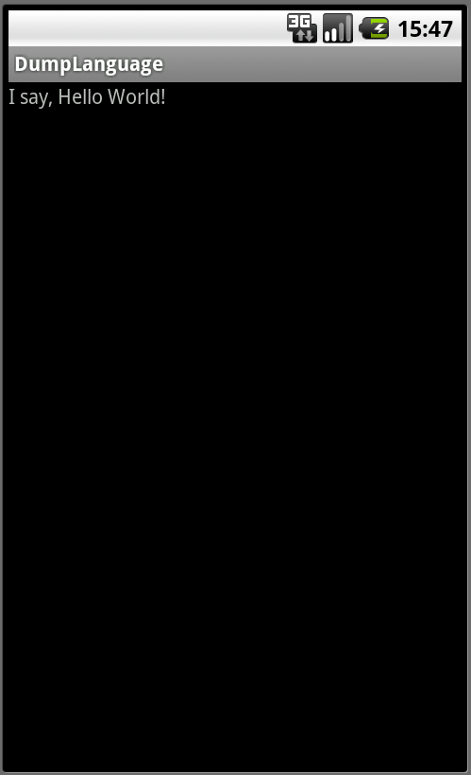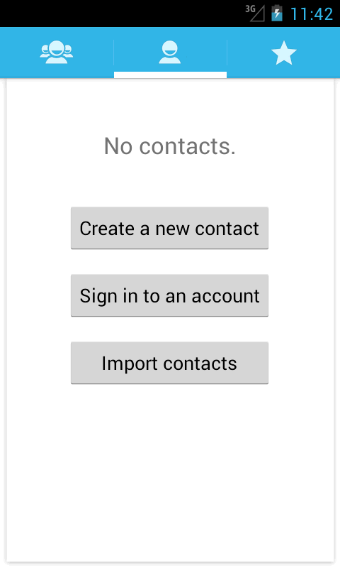

--- New page = insert page break for1(b) etc.
1 (b) <task description copied from page 1>
Completed? Yes/ No

